**Overview of Form Assembly**

* Online Form with a second stage of compiling all data into one sheet with tight security protocols and the integration capabilities to analyse that data
* Examples of companies that use FormAssembly: American Red Cross, Harvard University, T-Mobile, Teach for America (strong Non-Profit consumer base)
* Tend do be for donation forms, applications and customer feedback

**Use Cases and Benefits**

* High Data Security and Compliance
* Integration Capabilities
  + Pre-built connectors like Salesforce, Google Sheets, DropBox
  + External ones
* Payment Gateways (Paypal, Authorize.net)
* Database Integration (MySQL, Microsoft SQL)
* Email Marketing (MailChimp)
* WebHooks - sends data as HTTP POST to connect with other applications

**More About Form Creation**

* Has Drag-&-Drop Form Builder interface which is extremely easy and intuitive to use
* Contains Conditional Logic: show or hide form fields based on previous information entered
* Form Templates available to use

**Within BBBSEM**

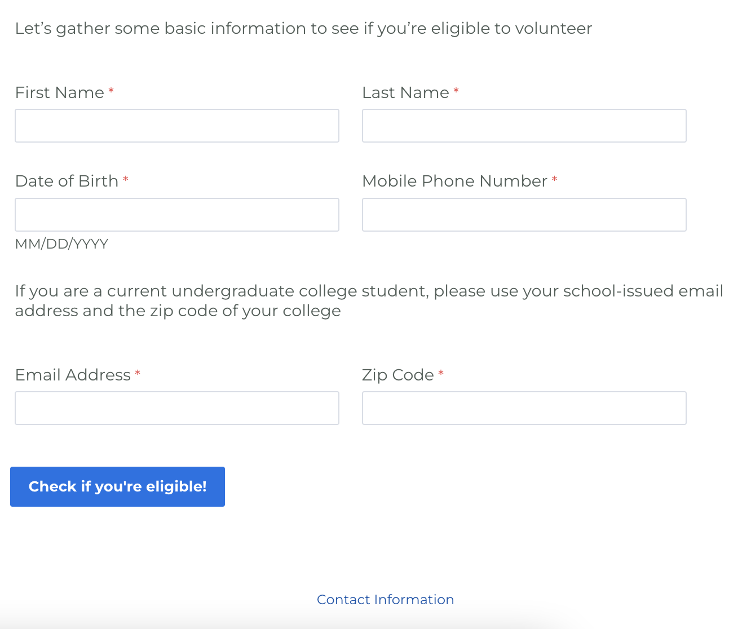

->> Filling out the form is **simple** and **quick**

Sources:

<https://www.formassembly.com/integrations/>

<https://help.formassembly.com/help/connect-your-web-form>

<https://www.salesforceben.com/formassembly-in-depth-review/>